HRBMP Fall Juvenile Survey Bi-weekly Report

Stony Brook University, School of Marine and Atmospheric Science & Normandeau Associates, InC.

RIVER RUN 9, Date: 10/07/24-10/11/24

# 0. Brief abstract

The Fall Juvenile Survey (FJS) is designed to provide data on juvenile fish in the Hudson River Estuary (HRE) to support calculation of standing crop and temporal and geographic indices for selected key HRE fish species. The FJS spans the entire HRE. Starting with River Run 9, sampling was exclusively conducted during daytime (defined as 30 minutes after sunrise to 30 minutes before sunset).

Two types of gear are used for surveying: beam trawl and Tucker trawl. During River Runs 9-11, only beam trawls will be used. In situ measurements of water temperature (°C), dissolved oxygen (mg/L), specific conductivity (microsiemens/cm at 25°C), salinity (ppt), and turbidity (NTU) were collected at 65 fixed stations at approximately three-mile intervals along the length of the HRE.

During the first 3 River Runs, all young-of-year (YOY) fish within each region caught were placed in sample containers, preserved with 70% ethanol, and taken to the laboratory for identification and enumeration. After the first 3 River Runs, only up to 60 YOY fish of each key species within each region caught will be placed and preserved in sample containers and taken to the laboratory for identification and enumeration. All yearling and adult fish were identified, sorted by length class, counted and returned to the water alive, if possible. All key species brought back to the laboratory were sorted by species and length and weight were measured. All length measurements were taken to the nearest millimeter (mm) total length, and weights measured to the nearest centigram (g). All fish brought back to the laboratory were preserved in 70% ethanol for 4-9 days before measurements were taken from them.

*Note: all the data used for this bi-weekly report are preliminary and have not undergone full QC audits.

# 1. Summary of weekly sampling protocol

For river run 9 (October 07 2024 to October 11 2024): there were 150 planned tows; no sample sites were affected by low D.O. (>4.5 mg/l) or high Temp (>28°C). 150 valid samples were collected.

* No sturgeon were caught.
* No Round Goby were caught.
* 30 Blue Crabs were caught.
* Heavy ctenophores caught in beam trawls in regions 1 and 2.
* No major problems were encountered.

**Table 1.1 Summary of sampling status; BT= Beam Trawl**

| riv.region.code | riv.region | river.mile.range | BT |
| --- | --- | --- | --- |
| 0 | Battery | 1-11 | 12 |
| 1 | Yonkers | 12-23 | 16 |
| 2 | Tappan Zee | 24-33 | 13 |
| 3 | Croton-Haverstraw | 34-38 | 11 |
| 4 | Indian Point | 39-46 | 15 |
| 5 | West Point | 47-55 | 12 |
| 6 | Cornwall | 56-61 | 15 |
| 7 | Poughkeepsie | 62-76 | 10 |
| 8 | Hyde Park | 77-85 | 10 |
| 9 | Kingston | 86-93 | 8 |
| 10 | Saugerties | 94-106 | 10 |
| 11 | Catskill | 107-124 | 10 |
| 12 | Albany | 125-151 | 8 |
| Total | Total | Total | 150 |

# 2. Catch information from the field

## 2.1 Counts by species by region

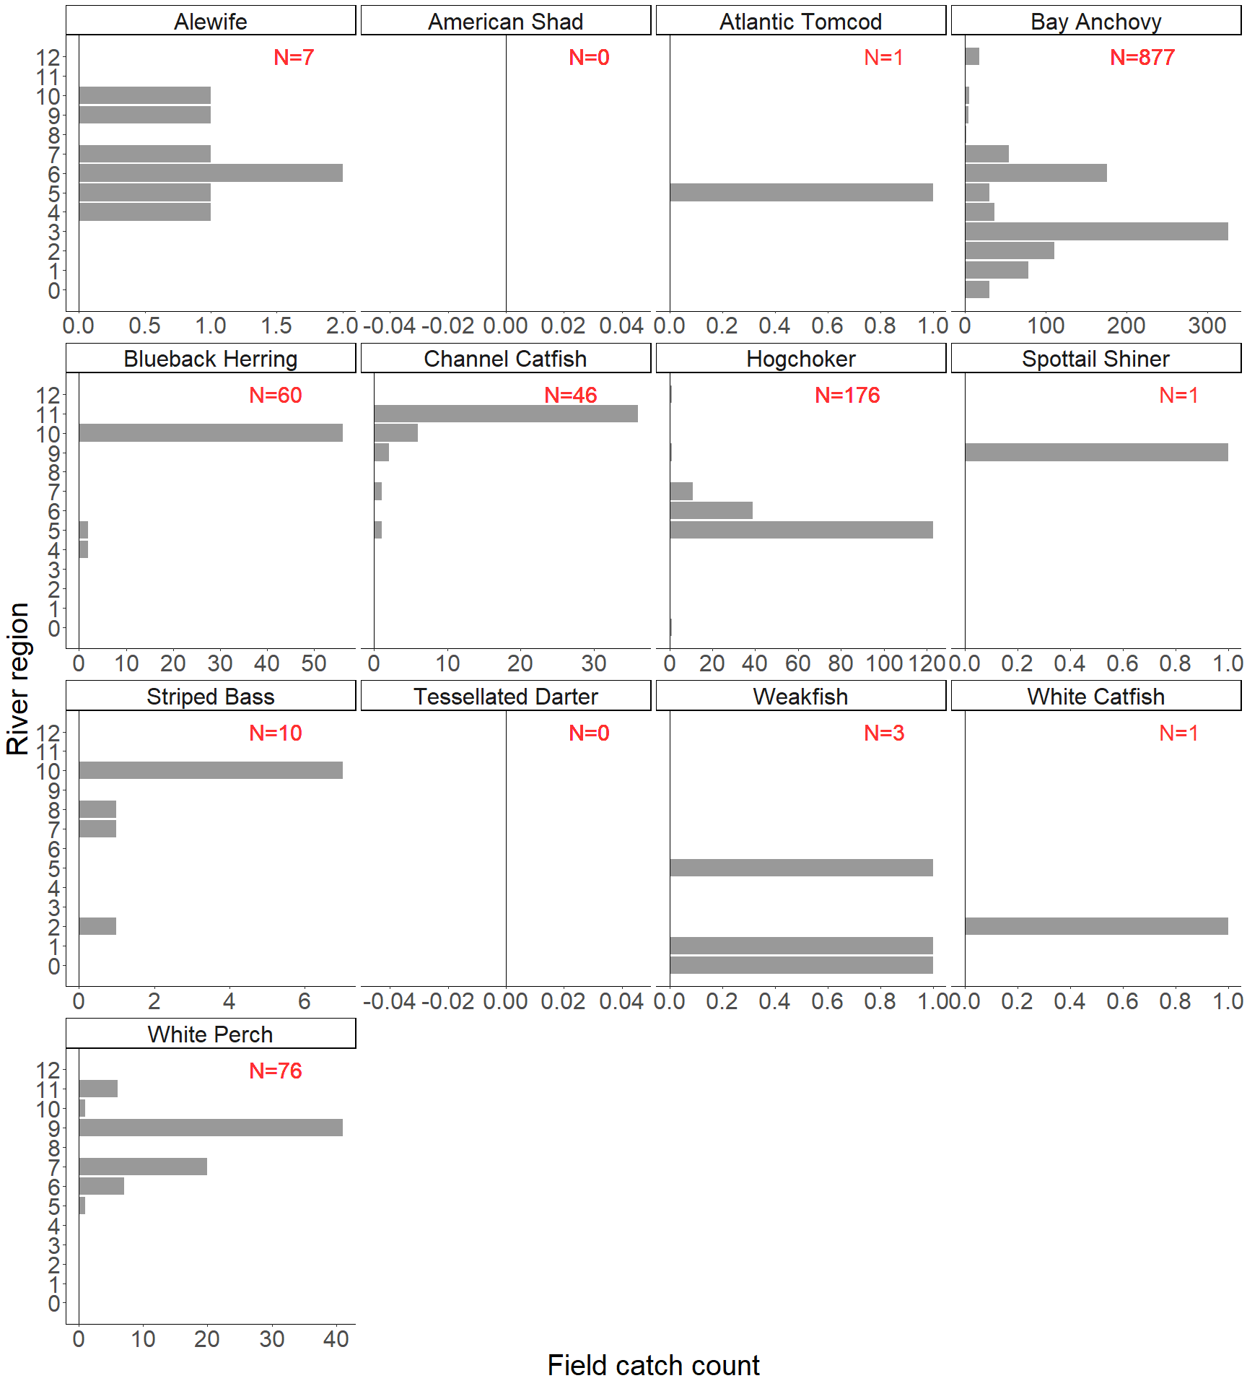

**Figure 2.1 Field Catch Count by Species by Region for 13 key species. The total catch count for each species is denoted with the N in each panel. Key species with zero catch is also shown here. For river run 1-3 all length class 1 fish are brought back to lab and not included in the field catch information.**

## 2.2 Spatial distribution of total catch

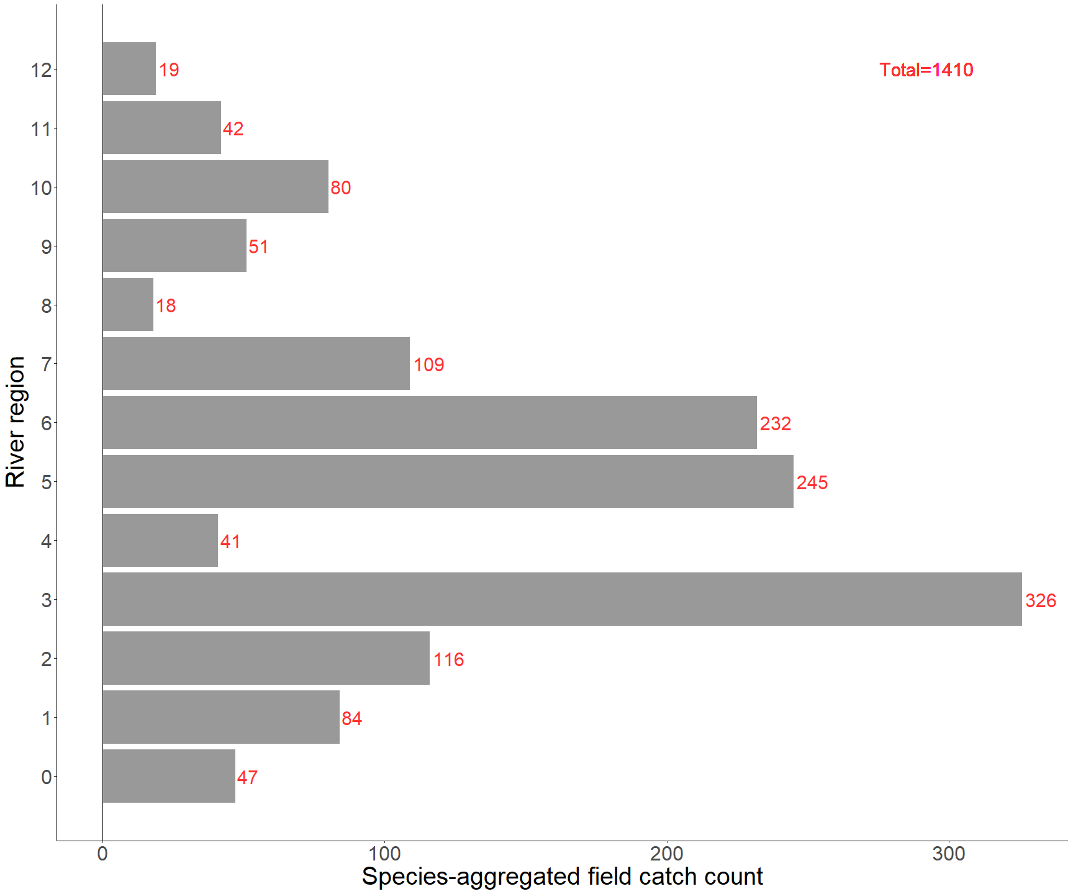

**Figure 2.2 Field Catch Count by Region. The total catch count for each region is denoted with red numbers. For river run 1-3 all length class 1 fish are brought back to lab and not included in the field catch information.**

# 3. Biological information of key species

## 3.1 Filter key species

13 key species (Alewife, American Shad, Atlantic Tomcod, Bay Anchovy, Blueback Herring, Channel Catfish, Hogchoker, Spottail Shiner, Striped Bass, Tessellated Darter, Weakfish, White Catfish, and White Perch)

## 3.2 Size composition (length and weight) and outliers

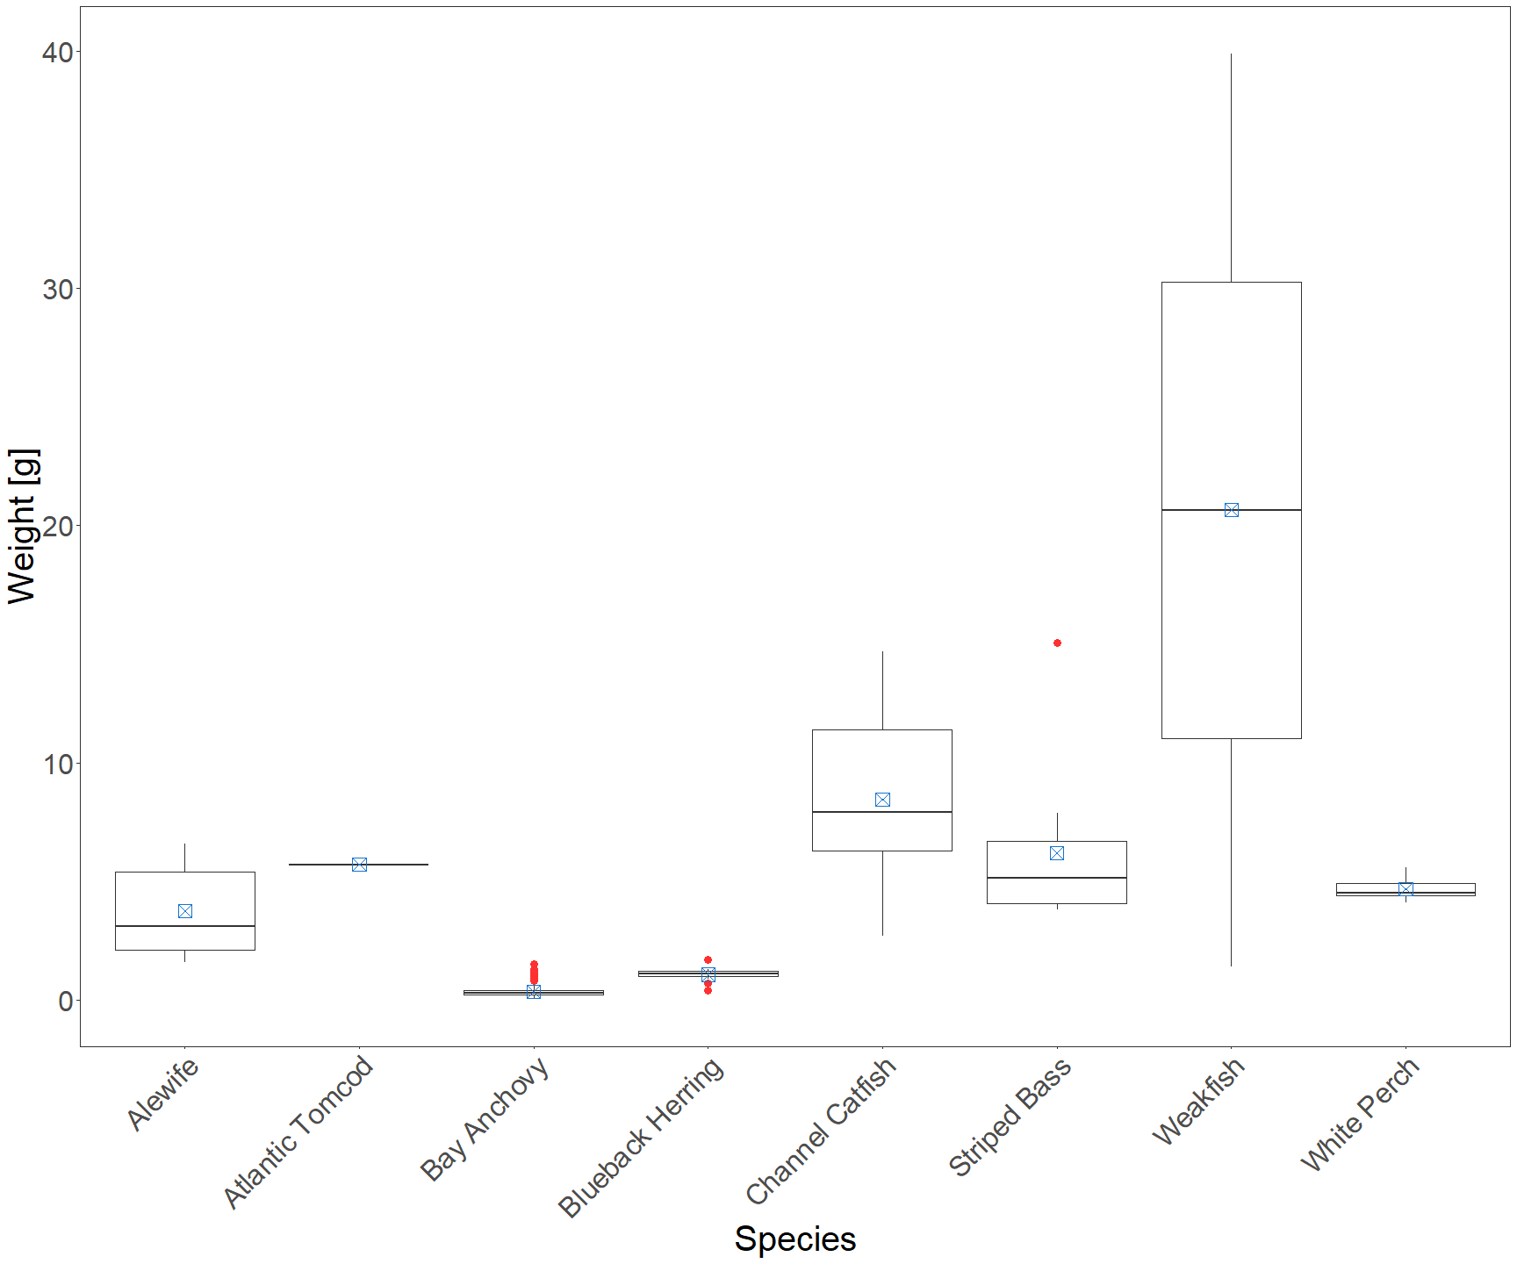

**Figure 3.2.1 Weight box-plot, red dots represent for outliers, blue boxes represent for mean values.**

Outliers are defined as larger than “Q3 + 1.5*IQR” or smaller than “Q1 - 1.5*IQR”.

**Table 3.2.1 Outliers in weight data**

| SAMPLE | RIV_RUN | COLL_DT | WEIGHT | SPECIES | mean.weight |
| --- | --- | --- | --- | --- | --- |
| 1392 | 9 | 2024-10-07 | 1.00 | Bay Anchovy | 0.360 |
| 1857 | 9 | 2024-10-08 | 0.80 | Bay Anchovy | 0.360 |
| 1857 | 9 | 2024-10-08 | 0.80 | Bay Anchovy | 0.360 |
| 1857 | 9 | 2024-10-08 | 0.90 | Bay Anchovy | 0.360 |
| 1857 | 9 | 2024-10-08 | 0.90 | Bay Anchovy | 0.360 |
| 1857 | 9 | 2024-10-08 | 1.00 | Bay Anchovy | 0.360 |
| 1857 | 9 | 2024-10-08 | 1.10 | Bay Anchovy | 0.360 |
| 1857 | 9 | 2024-10-08 | 1.10 | Bay Anchovy | 0.360 |
| 1867 | 9 | 2024-10-08 | 1.10 | Bay Anchovy | 0.360 |
| 1869 | 9 | 2024-10-08 | 1.20 | Bay Anchovy | 0.360 |
| 1874 | 9 | 2024-10-08 | 0.80 | Bay Anchovy | 0.360 |
| 1876 | 9 | 2024-10-09 | 1.50 | Bay Anchovy | 0.360 |
| 1908 | 9 | 2024-10-09 | 0.90 | Bay Anchovy | 0.360 |
| 1923 | 9 | 2024-10-10 | 1.20 | Bay Anchovy | 0.360 |
| 1923 | 9 | 2024-10-10 | 1.00 | Bay Anchovy | 0.360 |
| 1923 | 9 | 2024-10-10 | 0.80 | Bay Anchovy | 0.360 |
| 1923 | 9 | 2024-10-10 | 1.00 | Bay Anchovy | 0.360 |
| 1923 | 9 | 2024-10-10 | 0.80 | Bay Anchovy | 0.360 |
| 1923 | 9 | 2024-10-10 | 0.90 | Bay Anchovy | 0.360 |
| 1923 | 9 | 2024-10-10 | 0.80 | Bay Anchovy | 0.360 |
| 1924 | 9 | 2024-10-10 | 0.90 | Bay Anchovy | 0.360 |
| 1925 | 9 | 2024-10-10 | 1.30 | Bay Anchovy | 0.360 |
| 1925 | 9 | 2024-10-10 | 0.90 | Bay Anchovy | 0.360 |
| 1925 | 9 | 2024-10-10 | 0.80 | Bay Anchovy | 0.360 |
| 1925 | 9 | 2024-10-10 | 0.90 | Bay Anchovy | 0.360 |
| 1926 | 9 | 2024-10-10 | 0.90 | Bay Anchovy | 0.360 |
| 1927 | 9 | 2024-10-10 | 1.10 | Bay Anchovy | 0.360 |
| 1928 | 9 | 2024-10-10 | 1.30 | Bay Anchovy | 0.360 |
| 1931 | 9 | 2024-10-10 | 1.10 | Bay Anchovy | 0.360 |
| 1931 | 9 | 2024-10-10 | 1.30 | Bay Anchovy | 0.360 |
| 1931 | 9 | 2024-10-10 | 0.90 | Bay Anchovy | 0.360 |
| 1940 | 9 | 2024-10-10 | 0.80 | Bay Anchovy | 0.360 |
| 1866 | 9 | 2024-10-08 | 0.40 | Blueback Herring | 1.068 |
| 1873 | 9 | 2024-10-08 | 0.70 | Blueback Herring | 1.068 |
| 1894 | 9 | 2024-10-09 | 1.70 | Blueback Herring | 1.068 |
| 1914 | 9 | 2024-10-10 | 15.07 | Striped Bass | 6.203 |

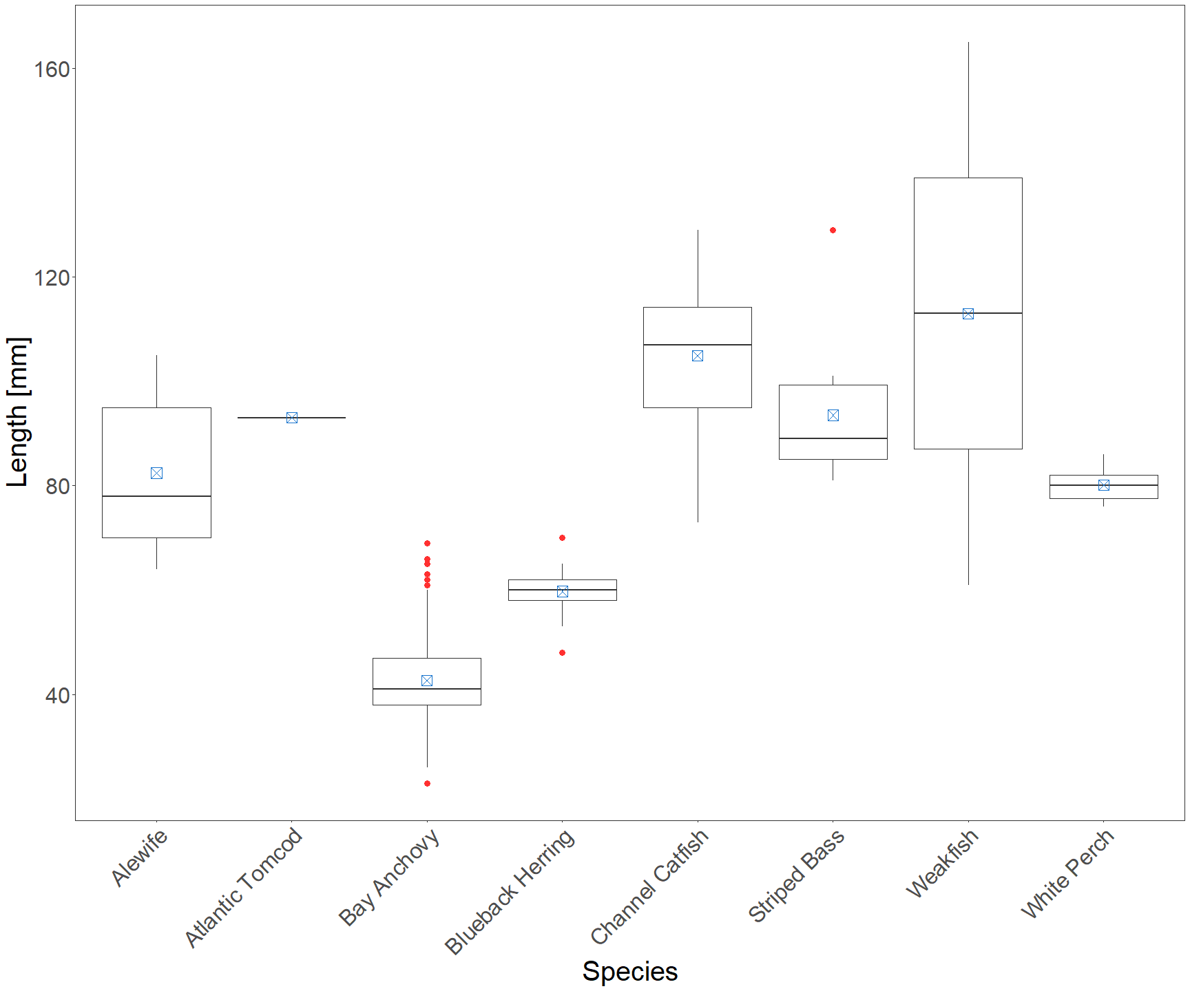

**Figure 3.2.2 Length box-plot, red dots represent for outliers, blue boxes represent for mean values.**

Outliers are defined as larger than “Q3 + 1.5*IQR” or smaller than “Q1 - 1.5*IQR”.

**Table 3.2.2 Outliers in length data**

| SAMPLE | LENGTH | RIV_RUN | COLL_DT | SPECIES | mean.length |
| --- | --- | --- | --- | --- | --- |
| 1857 | 61 | 9 | 2024-10-08 | Bay Anchovy | 42.6485 |
| 1857 | 63 | 9 | 2024-10-08 | Bay Anchovy | 42.6485 |
| 1867 | 62 | 9 | 2024-10-08 | Bay Anchovy | 42.6485 |
| 1869 | 66 | 9 | 2024-10-08 | Bay Anchovy | 42.6485 |
| 1876 | 69 | 9 | 2024-10-09 | Bay Anchovy | 42.6485 |
| 1918 | 23 | 9 | 2024-10-10 | Bay Anchovy | 42.6485 |
| 1923 | 62 | 9 | 2024-10-10 | Bay Anchovy | 42.6485 |
| 1925 | 63 | 9 | 2024-10-10 | Bay Anchovy | 42.6485 |
| 1927 | 63 | 9 | 2024-10-10 | Bay Anchovy | 42.6485 |
| 1928 | 69 | 9 | 2024-10-10 | Bay Anchovy | 42.6485 |
| 1931 | 62 | 9 | 2024-10-10 | Bay Anchovy | 42.6485 |
| 1931 | 65 | 9 | 2024-10-10 | Bay Anchovy | 42.6485 |
| 1866 | 48 | 9 | 2024-10-08 | Blueback Herring | 59.7600 |
| 1894 | 70 | 9 | 2024-10-09 | Blueback Herring | 59.7600 |
| 1914 | 129 | 9 | 2024-10-10 | Striped Bass | 93.5000 |

## 3.3 2-D outliers for length and weight

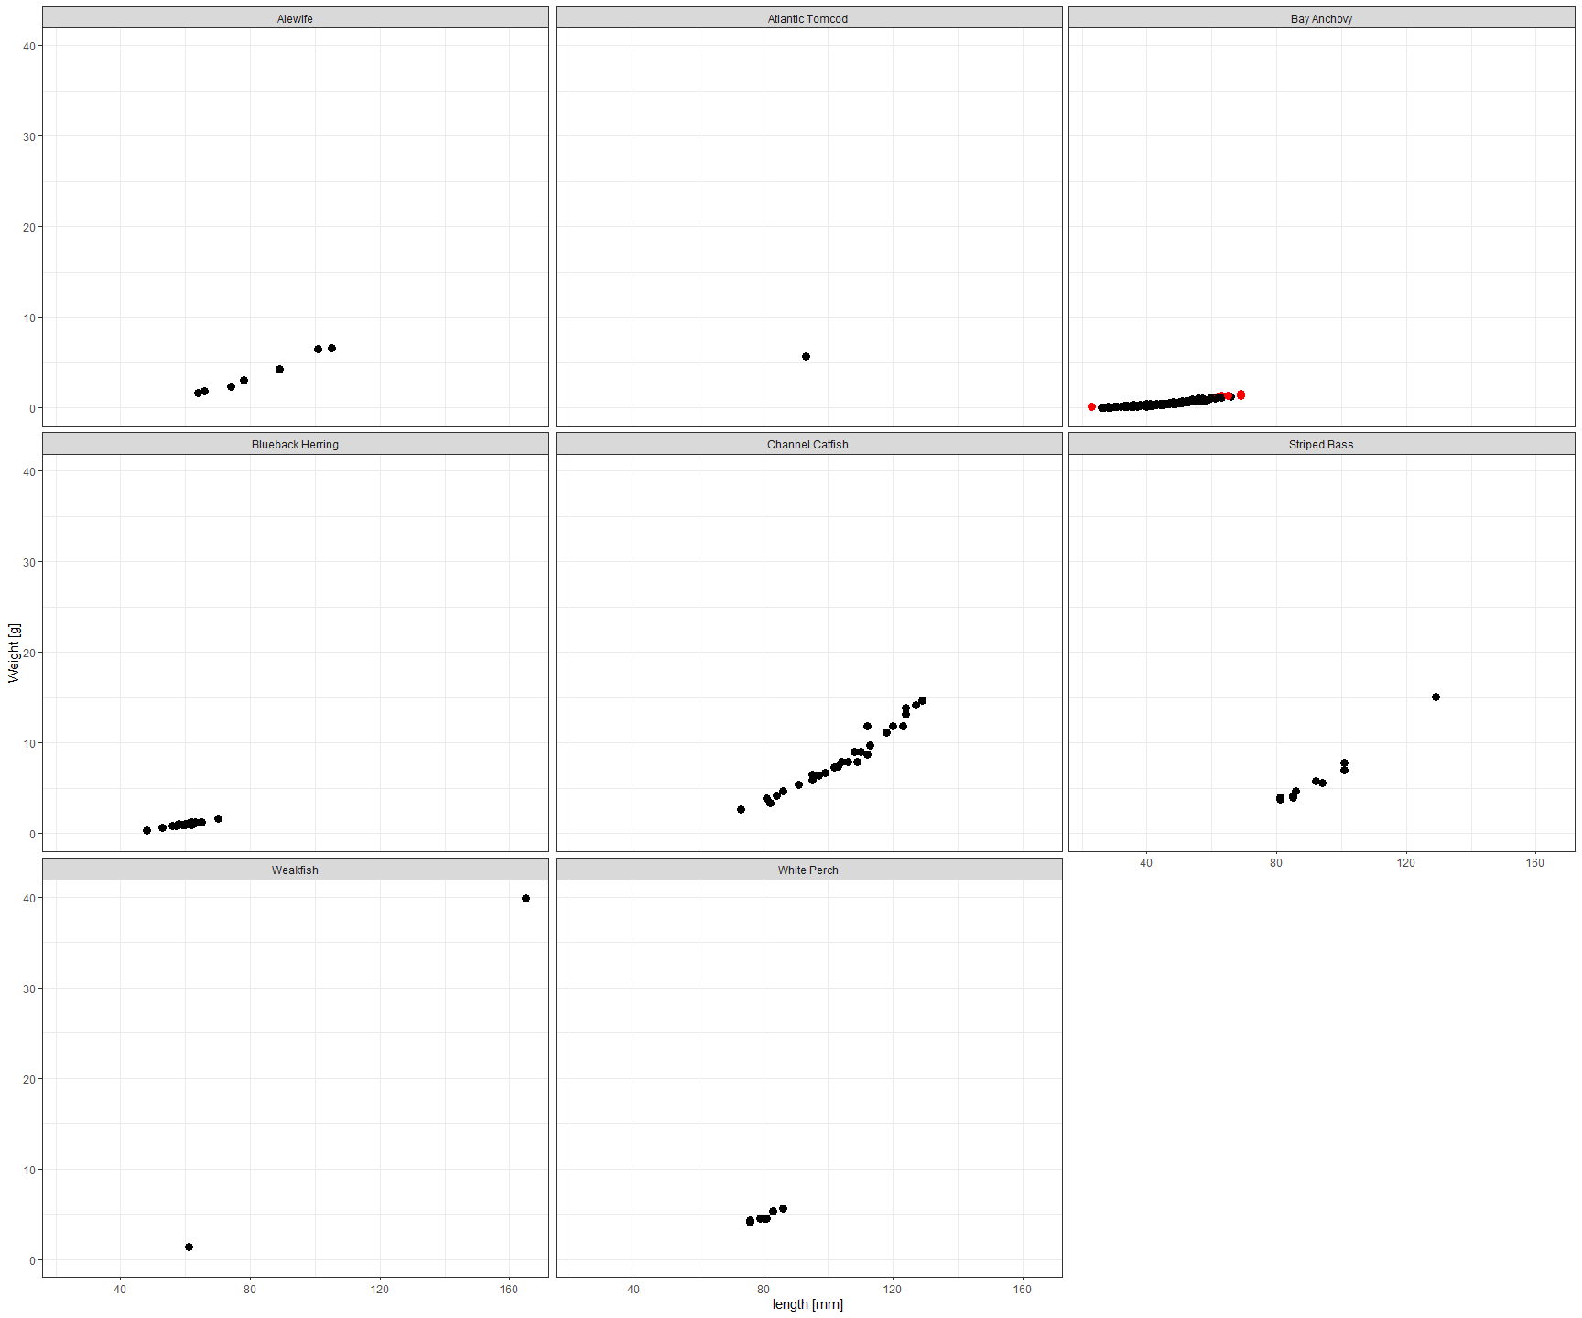

**Figure 3.3.1 Two-dimensional length-weight distribution, red dots representing the outliers. The Mahalanobis distance is used to identify the outliers in the two-dimensional length-weight data distribution. It uses a multi-dimensional generalization to measures the standard deviations of each data point P from the mean of the overall distribution D. This distance is zero for P at the mean of D and grows as P moves away from the mean along each principal component axis. The Mahalanobis distance is unitless, scale-invariant, and accounts for the correlations of the data set.**

**Table 3.3.1 Outliers in 2-D length weight data**

| SAMPLE | LENGTH | WEIGHT | RIV_RUN | COLL_DT | SPECIES |
| --- | --- | --- | --- | --- | --- |
| 1876 | 69 | 1.50 | 9 | 2024-10-09 | Bay Anchovy |
| 1918 | 23 | 0.09 | 9 | 2024-10-10 | Bay Anchovy |
| 1923 | 62 | 1.20 | 9 | 2024-10-10 | Bay Anchovy |
| 1925 | 63 | 1.30 | 9 | 2024-10-10 | Bay Anchovy |
| 1928 | 69 | 1.30 | 9 | 2024-10-10 | Bay Anchovy |
| 1931 | 65 | 1.30 | 9 | 2024-10-10 | Bay Anchovy |

# 4. Large Hudson River ecosystem fish community indices

Including species richness; species diversity; species evenness and fish species composition.

Species richness S is used to represent the richness, the higher the richer.

Diversity is represented by Shannon-Wiener diversity index H and Simpson diversity 1-D:

Shannon-Wiener diversity index H, H = -sum(Pi * ln(Pi)), where Pi is the weight proportion of ith species to total weight; the higher the H value, the higher the diversity.

Simpson diversity 1-D (denoted as “SD” in table below), D = sum(n*(n-1))/N*(N-1) , where n is the number of species i, N is the total number of all species; the higher the 1-D value, the higher the diversity.

Species evenness is represented using Pielou index J, J = H/ln(S), where H is the SW index and S is the number of species. The Pielou index value is defined between 0 and 1. 1 represents a community with perfect evenness, and it decreases to zero as the relative abundances of the species diverge from evenness.

**Table 4 Larger Hudson River fish community indices**

|  | INDICES | VALUES |
| --- | --- | --- |
| S | Species richness | 21.0000000 |
| H | Shannon-Wiener diversity index | 1.3702553 |
| SD | Simpson diversity | 0.5840378 |
| J | Pielou index | 0.4500723 |

# 5. Pairwise plots

Pairwise plots for variables collected in the survey to showcase possible relationships that may aid in identification of outliers, the interpretation and application of data and samples.

* A big matrix to have plots for each pair of variables in the lower triangle and correlation coefficients in the upper triangle.  The diagonal plots will be variable’s frequency distribution
* Sample. No, depth, DOY, gear, Rkm, Time (More variables may applied)

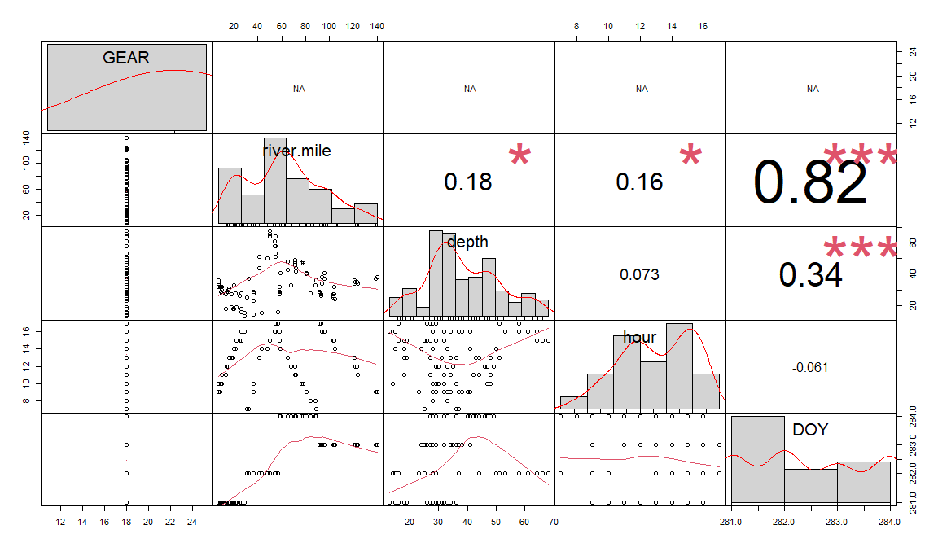

**Figure 5 Pairwise plots for variables collected in the survey, the values represent for correlation index, the numbers of red dots indicating the significant level.**

# 6. Special events

## 6.1 Shortnose Sturgeon (Acipenser brevirostrum) and Atlantic Sturgeon (Acipenser oxyrinchus)

No Sturgeon were caught in this river run.

## 6.2 Round goby

No Round goby were caught in this river run.